We installed on a VM on an HP DL380G4 server running VMWare

Solaris osol-0906-x86.iso for the OS build on a DL380G4 server running VMWare
ant 1.8.1
ejbca_3_10_1.zip
jce_policy-6.zip
jdk-1_5_0_22-nb-6_7_1-solaris-x86-ml.sh
- Java Platform, enterpsise Edition 5 SDKincludes GlassFish Enterprise server v2.1.1 and JAVA development kit 6 update 20

NOTE: Use gtar, not Solaris TAR. Solaris tar truncates some GNU long file names and you can’t tell right away, as the app sort of works. Especially on the ant distribution.

Glassfish
Currently EJBCA works both with Glassfish v1 and v2 with the Derby/JavaDB database.
Don't forget to install 'Unlimited Strength Jurisdiction Policy Files' for Java.
*** Configure EJBCA ***
- Su to root for all commands.
- When replacing or changing ALL files, check permissions (ls –al) and make new file match the replaced or edited files permission profile.
-------------------Set these environments first------------------
export JAVA_HOME=/opt/SDK/jdk/jre
export PATH=$PATH:/opt/SDK/bin:/usr/local/bin
export PATH=$PATH:$JAVA_HOME/bin
export ANT_HOME=/usr/ant
export PATH=$PATH:$ANT_HOME/bin
export APPSRV_HOME=/opt/SDK
export EJBCA_HOME=/ejbca/ejbca_3_10_1
#Note: path prior to the directory ‘/dist’ under the ejbca distribution
export DERBY_HOME=$APPSRV_HOME/javadb

(to be safe, I put them in /etc/profile, ~/.profile, ~/.bashrc and ~/.bash_profile

Set the environment variable APPSRV_HOME to the directory where Glassfish is installed. For example APPSRV_HOME=/home/sun/glassfish. The variable must be available when working with EJBCA. (see above)
Edit conf/ejbca.properties, you should at least set appserver.type, appserver.home and logging.log4j.config.
Edit conf/database.properties, you should at least set datasource.jndi-name-prefix, and the database settings for your chosen database. Derby is supported for Glassfish, and default options for Derby should work.
Edit conf/web.properties, you should set desired values and also the http/s ports (default 8080 and 8181) for your installation.
Configuration of ejbcaws and xkms only have to be done in Glassfish v1.
On Glassfish v2 it deploys nicely, even though the functionality does not work completely.
See https://jira.primekey.se/browse/ECA-607 for details.
(Tips how to solve these probles are welcome.)
Edit conf/jaxws.properties and set 'ejbcaws.enabled=false'.
Edit conf/xkms.properties and set 'xkms.enabled=false'. (Default from EJBCA 3.10.)
Build ejbca with 'ant'.
Do 'ant clean' first if you have tried with different appservers, or database settings.
If you need to do ‘ant clean’ do this first:
‘asadmin stop-database’
‘asadmin stop-domain domain1’
Do ‘ant clean’
‘asadmin start-database’
‘asadmin start-domain domain1’
Skip to Glassfish deploy step

*** Configure Glassfish ***
Do yourself a favor and configure this in the JVM settings of Glassfish v1 (default in v2):
-XX:MaxPermSize=192mRestart Glassfish
Derby:
Start the database: asadmin start-database.
Create a database and a database user with privileges.
> cd /home/sun/glassfish/bin cd $APPSRV_HOME/bin
> export DERBY_HOME=/home/sun/glassfish/javadb; ..
>$APPSRV_HOME/javadb/bin/ij #invokes the Derby SQL language command line
(For glassfish v1 use this command instead: > export DERBY_HOME=/home/sun/glassfish/javadb; ../javadb/frameworks/NetworkServer/bin/ij.ksh)
ij> connect 'jdbc:derby://localhost:1527/ejbca;create=true';
ij> run '/home/sun/ejbca/doc/howto/create-tables-ejbca3-derby.sql';
ij> quit;
Start the application server: asadmin start-domain
The default user/password for the web console is admin/admin (but we set a different one).
Access the Glassfish admin console at http://127.0.0.1:4848/.
Create a connection pool for your database. In the admin console this is done in Resources->JDBC->Connection Pools.
When adding a Derby Pool use values: Name=EjbcaPool, Type=javax.sql.DataSource, Vendor=JavaDB.
Properties: user=APP, password=APP, DatabaseName=ejbca
NOTE: Be sure you database name, user and password in the database.properties file match the above line
Note: ij> command did not function. I needed to change permissions of the ij binary to execute for root. This may have been a one- time anomaly.
($APPSRV_HOME/javadb/bin is location)
Sample screen shot:
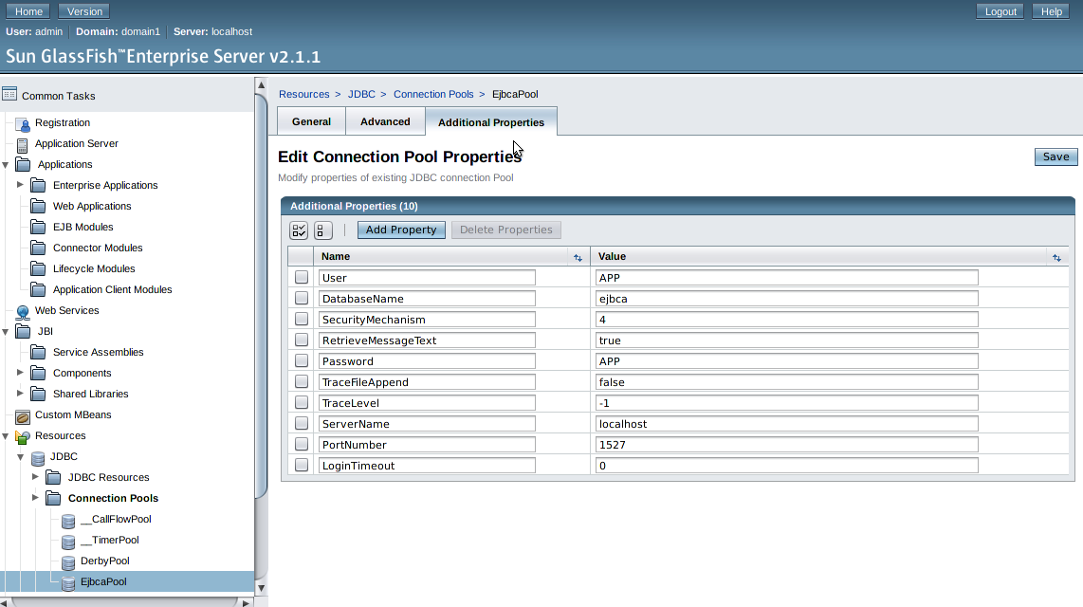
NOTE: Delete ’Ssl’ Property with value of ‘off’ if present. This caused problems in the Glassfish deployment
We found that we needed to exit glassfish after saving this Connection Pool and open glassfish again to check the connection pool we created.
- Go to the General tab of the EjbcaPool and Ping the data source.
  - Should get a Ping Succeeded result
- Go to the Additional Properties Tab
  - Make sure your User, DabaseName and Password are showing
  - If any are not there use Add Property to restore them (case and spelling are critical)
  - Exit and reenter Glassfish again to verify they are created.

Create a datasource called jdbc/EjbcaDS, in the admin console this is done in Resources->JDBC->JDBC Resources.
Use the connection pool you just created.
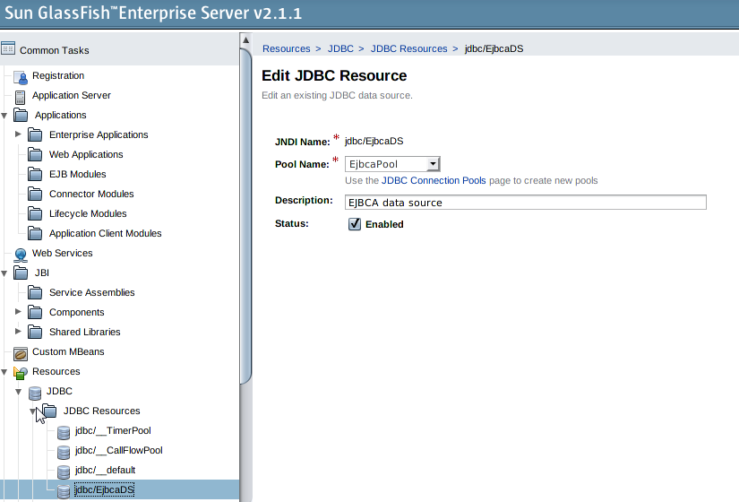

*** Deploy and setup ***
Deploy ejbca.ear using:
./asadmin deploy ../../ejbca/dist/ejbca.ear
asadmin deploy $EJBCA_HOME/dist/ejbca.ear
The relative path to ejbca.ear depends on where you installed ejbca and glassfish. You can check that everything was ok in domains/domain1/logs/server.log.
Install ejbca:
ant install
Configure SSL in Glassfish
Configuration->HTTP Service->HTTP Listeners->http-listener-2, SSL tab
Client Authentication: Enabled
Certificate Nickname: s1as (get alias name by running 'keytool -list -v -keystore $APPSRV_HOME/domains/domain1/config/keystore.jks', password changeit)
SSL3: Enabled
Ciphers Suite: All
Add CA certificate to cacerts file:
cd $EJBCA_HOME
bin/ejbca.sh ca getrootcert AdminCA1 ca.der -der
Install the CA certificate in the application servers truststore.
On Glassfish open source:
keytool -import -keystore $APPSRV_HOME/domains/domain1/config/cacerts.jks -file $EJBCA_HOME/ca.der
password is 'changeit'
On Glassfish Enterprise:
cd $APPSRV_HOME/domains/domain1/config
/usr/sfw/bin/certutil -A -n adminca1 -t "p,p,p" -i $EJBCA_HOME/ca.der -d .
verify that adminca1 has been added to the store with '/usr/sfw/bin/certutil -L -d .'.
Restart server
(you would probably want to install your own server certificate from $EJBCA_HOME/p12/tomcat.jks instead of the default Glassfish cert, to do this you must edit both the http-listener and the IIOP-listeners. You can also generate a new $APPSRV_HOME/domains/domain1/config/keystore.jks with key alias s1as, or even easier change the alias in tomcat.jks with keytool -changealias)
We haven’t tried the above yet
Access protected EJBCA pages
Import $EJBCA_HOME/p12/superadmin.p12 in your browser and go to url:
https://127.0.0.1:8181/ejbca/ substitute the port you set for https: in Glassfish and web.propterties for 8181
Import to the “Your Cerficates” tab, not the “Authorities” tab. That is the only tab that will see the superadmin.p12 certificate. When importing this will prompt for the password you set in the web.properties file (superadmin.password=ejbca as an example).
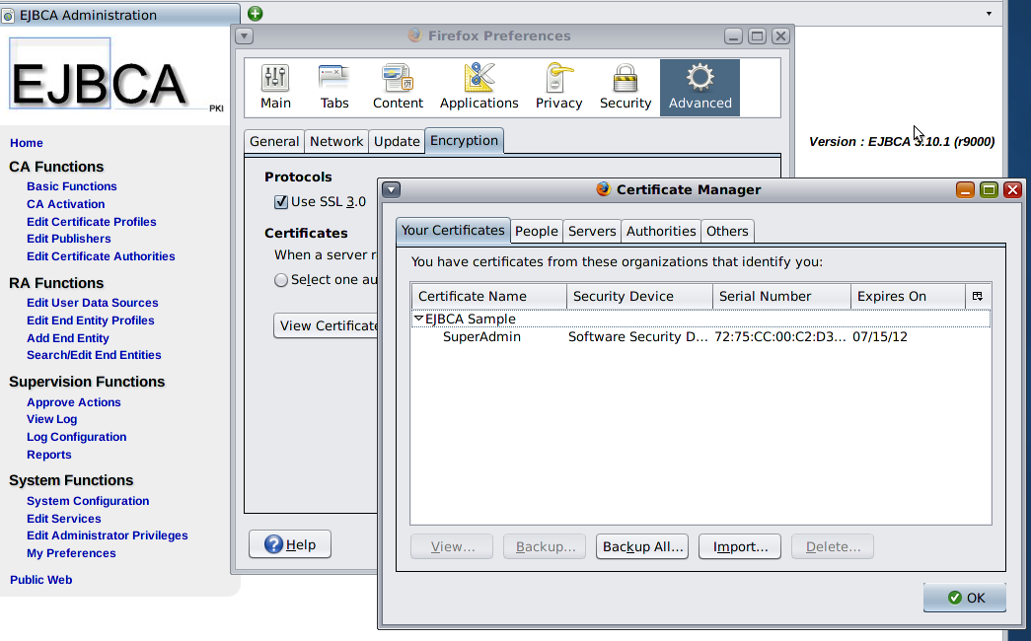

You can now click "Administration" to get to the admin-GUI.
In our case the Main Screen appeared in English (EN). The EJBCA Administration screen appeared in German (DE).

See screen shot below to fix:
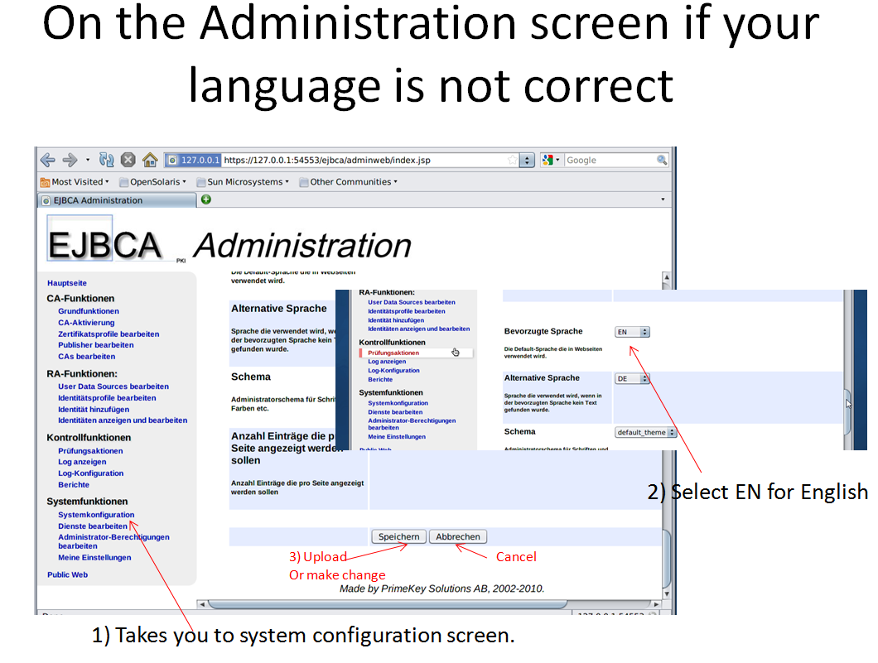

Return to Main screen and select EJBCA Administration. Your language should appear.

